CLOUD COMPUTING

ASSIGNMENT: 01



Submitted To:

Engr. Waqas Salim

Submitted By:

Komal Kashif

BSE V-A

2023-BSE-031

**TASK 1: RUN GITEA IN CODESPACE AND CREATE AN INITIAL REPO**

1. **Set up Gitea:**

Run Gitea inside Codespace:

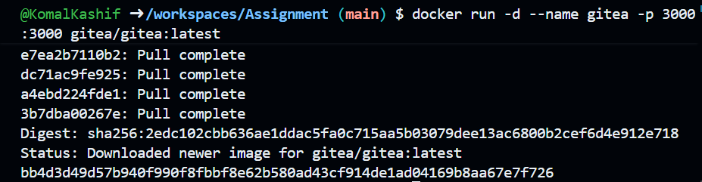

Forward the port to access Gitea:

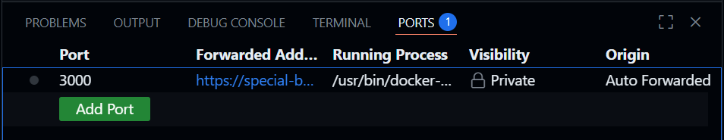

Set up Gitea in the browser:

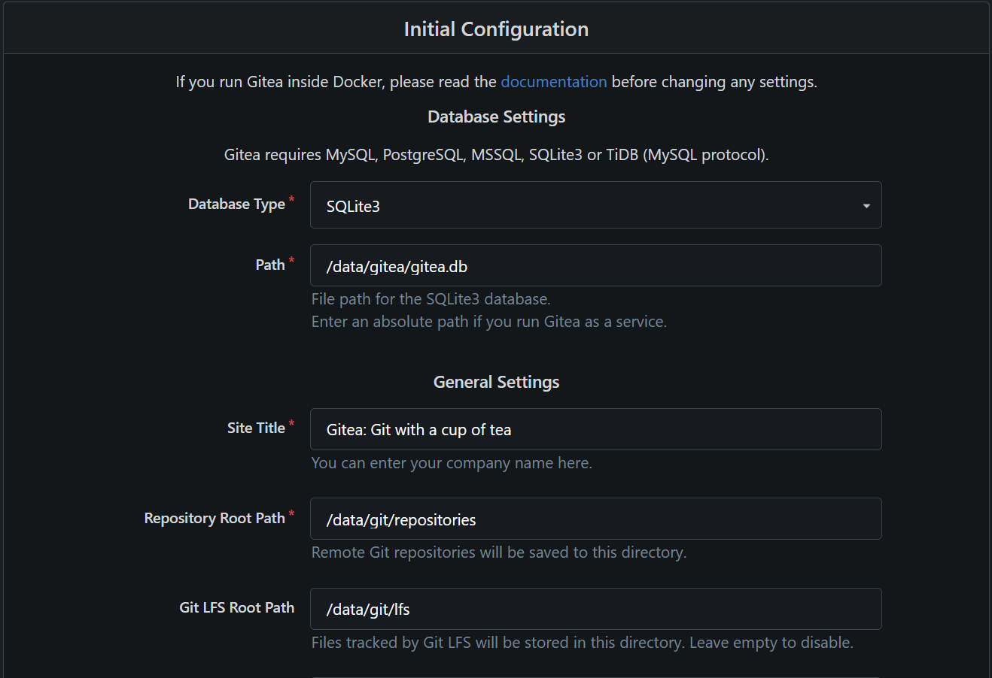

Create an admin account:

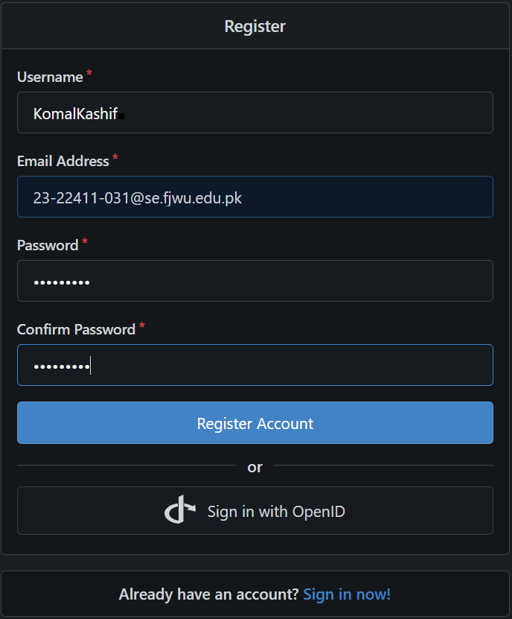

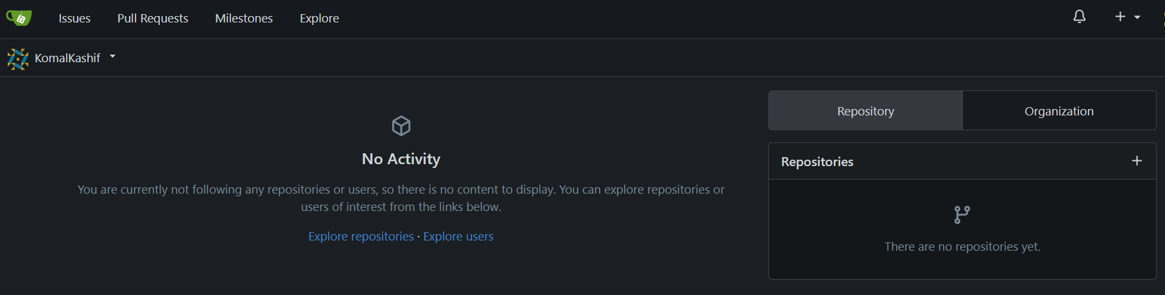

1. **Create a Repository:**

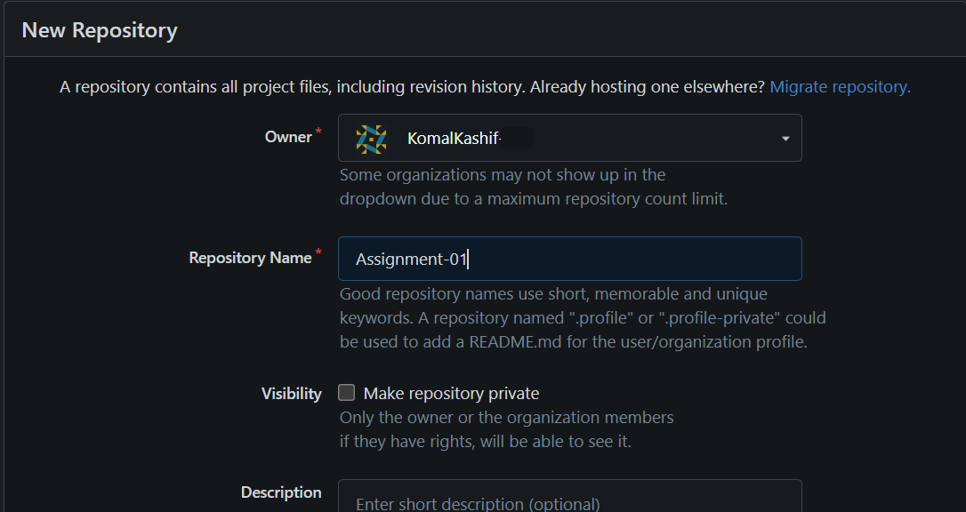

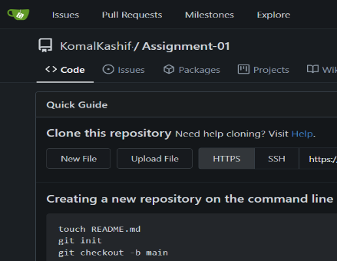

Now, add a **README.md** listing student names & roll numbers.

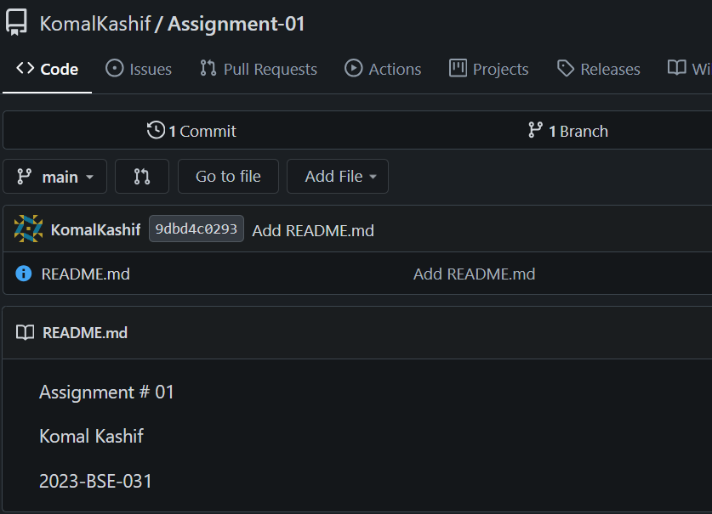

1. **Generate a Personal Access Token (PAT) in Gitea**

Open Settings 🡪 Applications to create token:

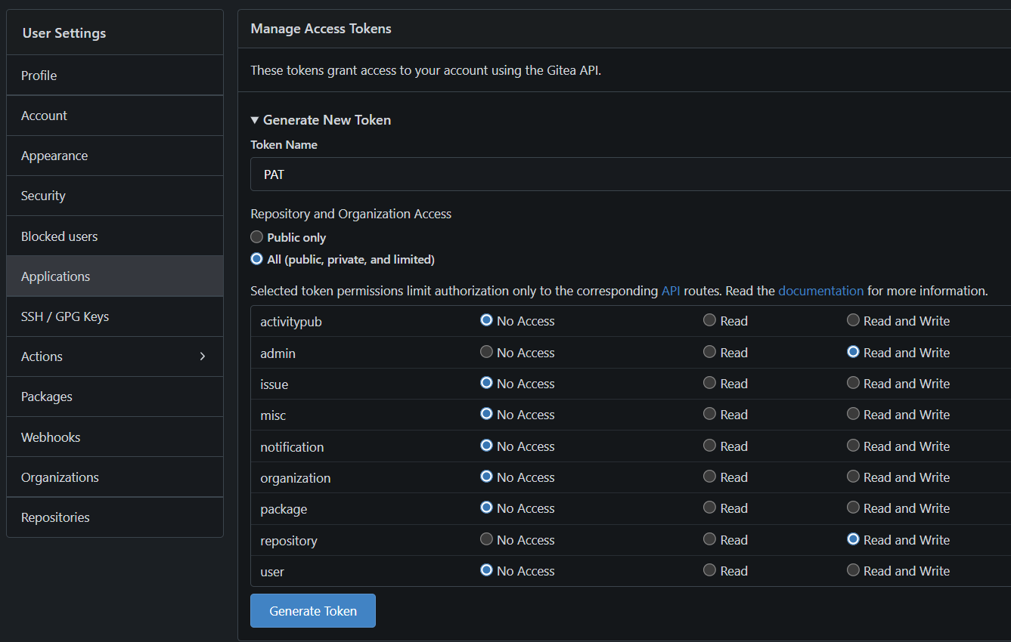

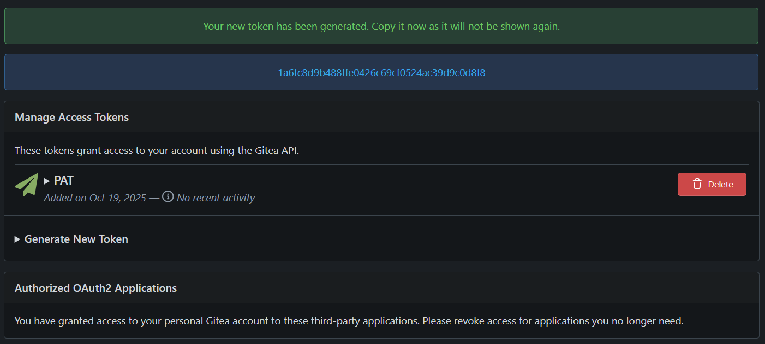

Now, open Git Bash:

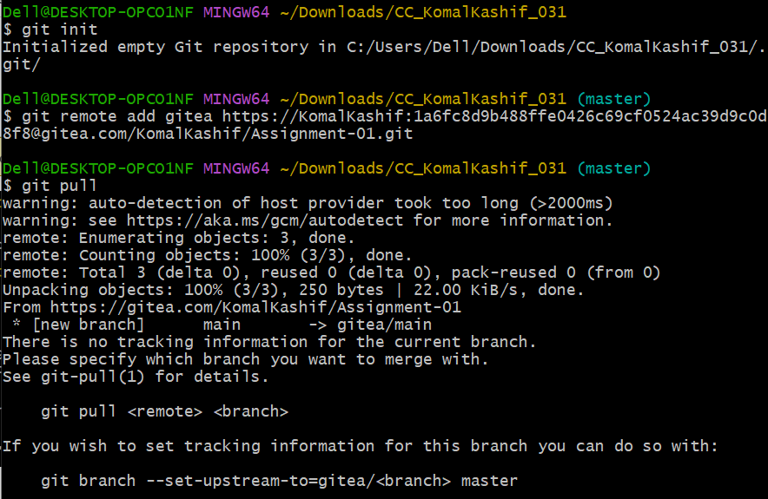

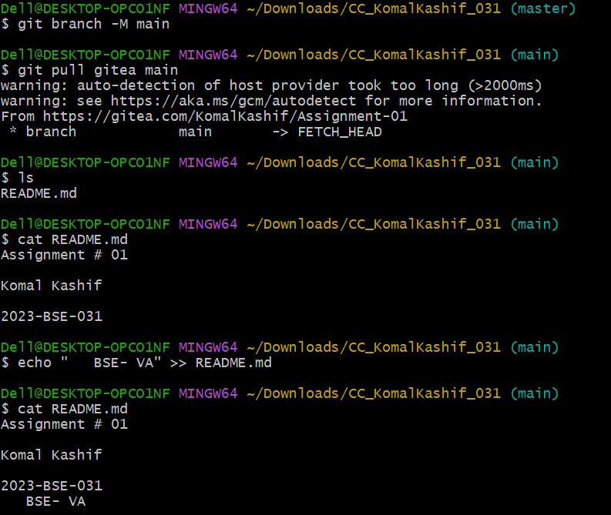

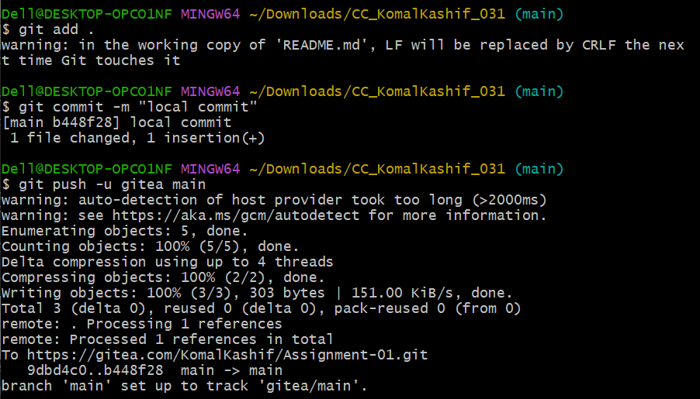

Go back to Gitea:

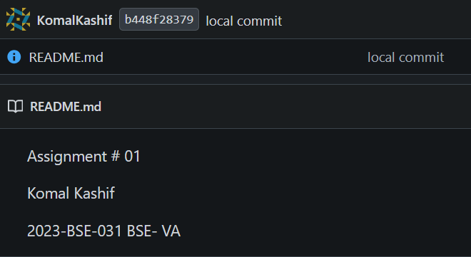

So the change we made locally also appeared here in the repository.

**TASK 2: MIRROR README.MD FROM GITEA TO GITHUB**

1. Continue Working with Your Existing Repository
2. Create Github repository named assignment1

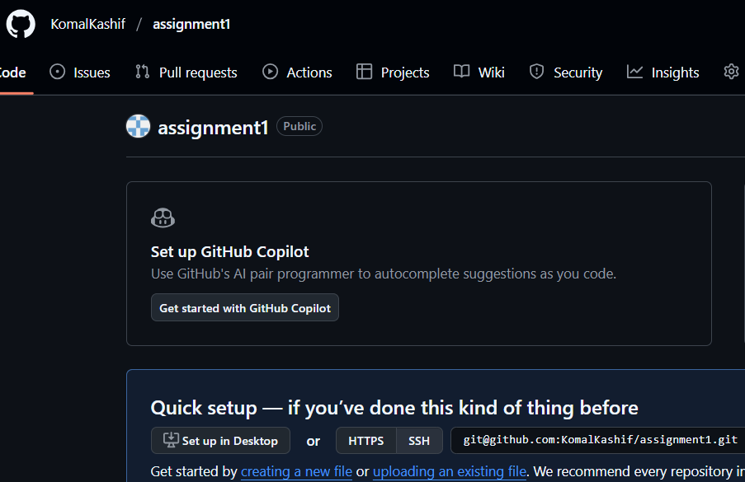

1. Add GitHub as a Second Remote.
2. Push the README.md File to GitHub.
3. Verify Remotes: Run git remote -v and ensure both remotes (gitea and github) are listed.

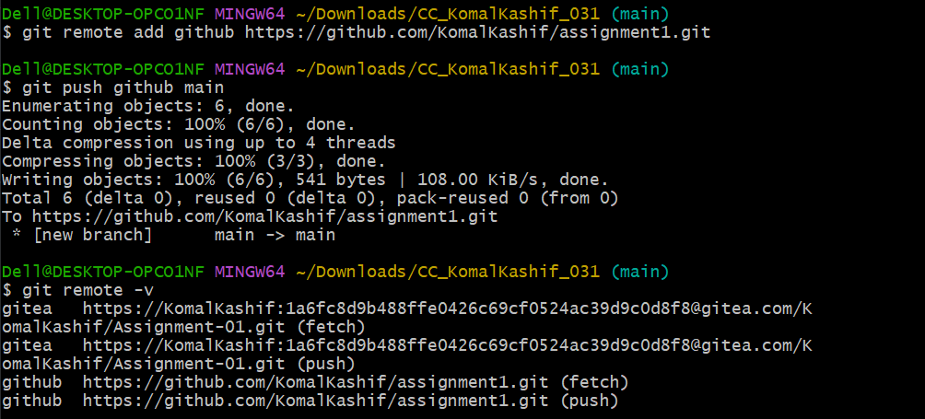

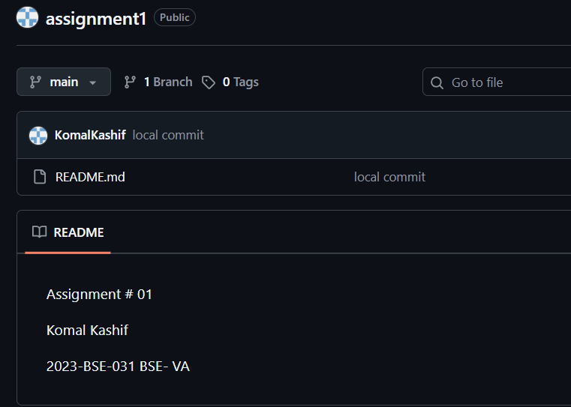

**TASK 3: USE GIT LFS FOR LARGE FILES**

1. **Install Git LFS:**

Set up Git LFS in your local repository.

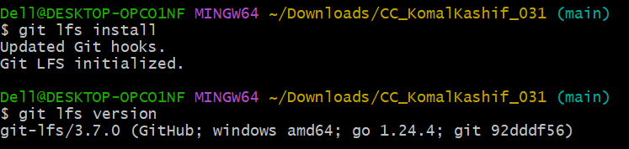

1. **Add Large Files:**

Add **three files larger than 100 MB** each to your repository. Track them using Git LFS: git lfs track "*.ext"

Replace .ext with the appropriate file extension.

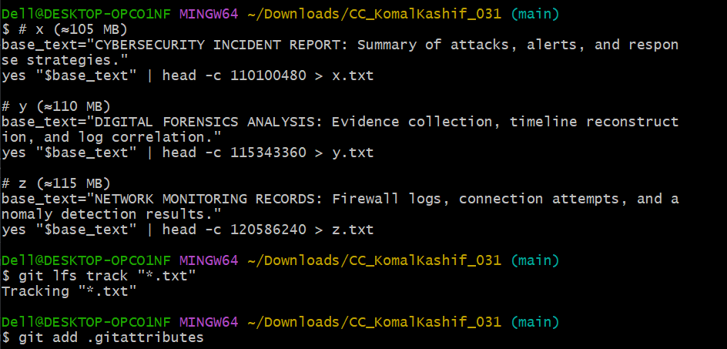

1. **Reference in Assignment Repo:**

Commit and push these large files to your GitHub assignment 1 repo.

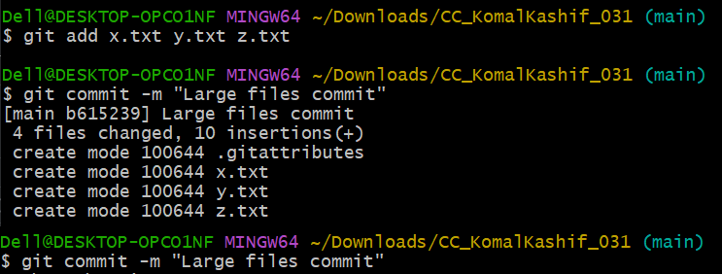

Ensure the files are referenced correctly in your repository history.

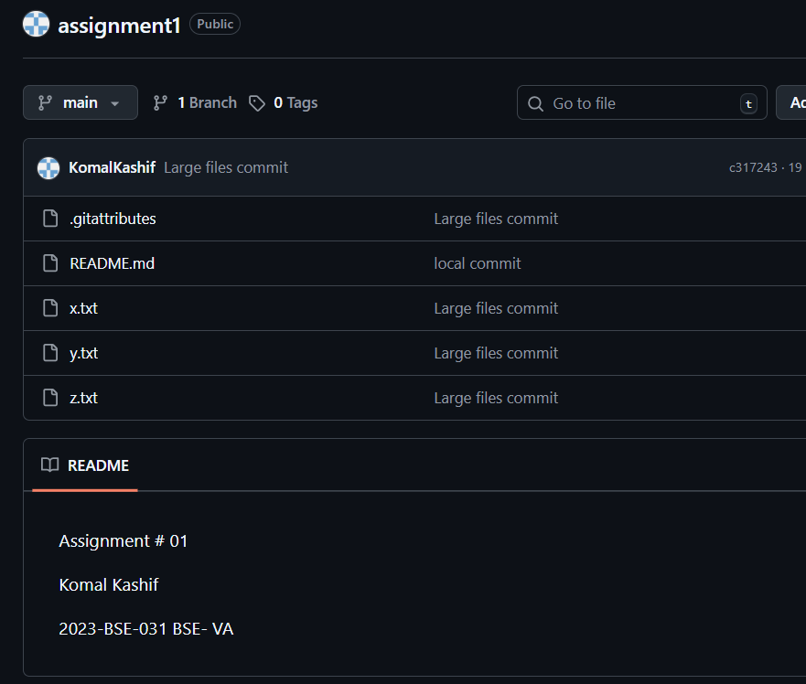

**TASK 4: CREATE A PORTFOLIO/CV WITH GITHUB PAGES**

Go to GitHub and create a new repository named <your-username>.github.io. Make sure the repository is public.

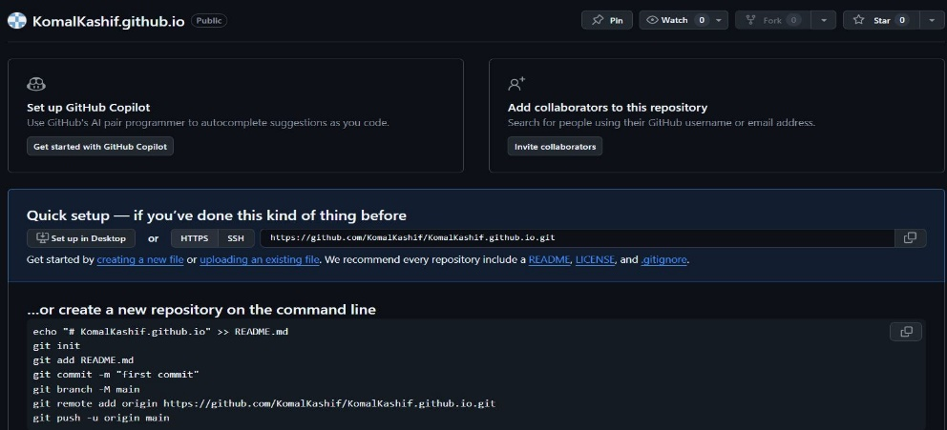

Push the Files to GitHub

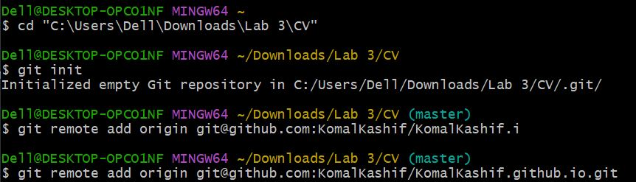

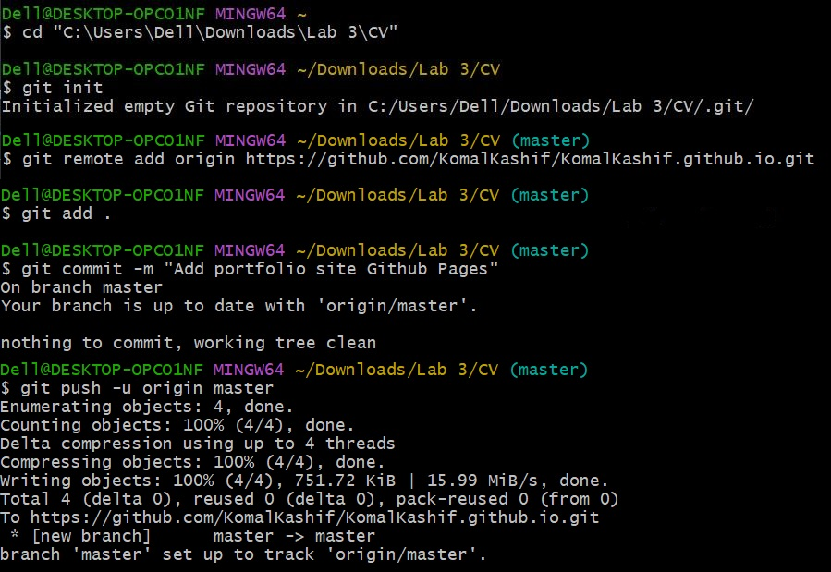

Go to your repository on GitHub. Click Settings > Pages. Confirm that your site is published and see the link to your live site (e.g., [https://your-username.github.io](https://your-username.github.io/)).

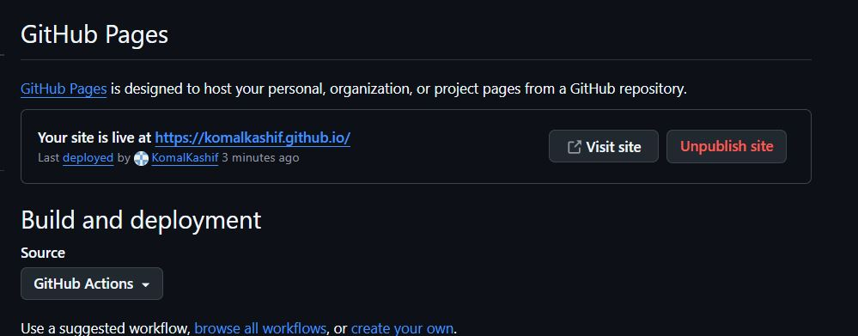

Visit Your Live Site

